Make Your Own Volcano!

You will need….

- Aluminum tin, or plate
- Baking soda (3-4 tablespoons)
- Vinegar (½ cup)
- A few drops of liquid dishwashing detergent
- Small plastic bottle
- Funnel
- Measuring cup
- Red food coloring
- ½ cup water

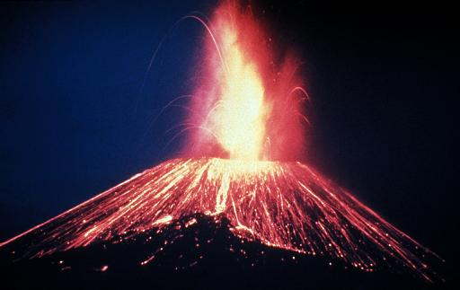
Let’s get started!!

- Put the plastic bottle on the aluminum tin or plate
- Mold the modeling clay around it in a volcano shape leaving the opening in the bottle.
- Using the funnel put the baking soda into the bottle.
- Then add the dishwashing detergent.
- Next add a ½ cup of water.
- Put a few drops of red food coloring into about ½ cup of vinegar.
- Now for the eruption! Using the funnel, pour the vinegar and food coloring mixture into the bottle and remove funnel.
- Then watch the volcano erupt!

